Overview
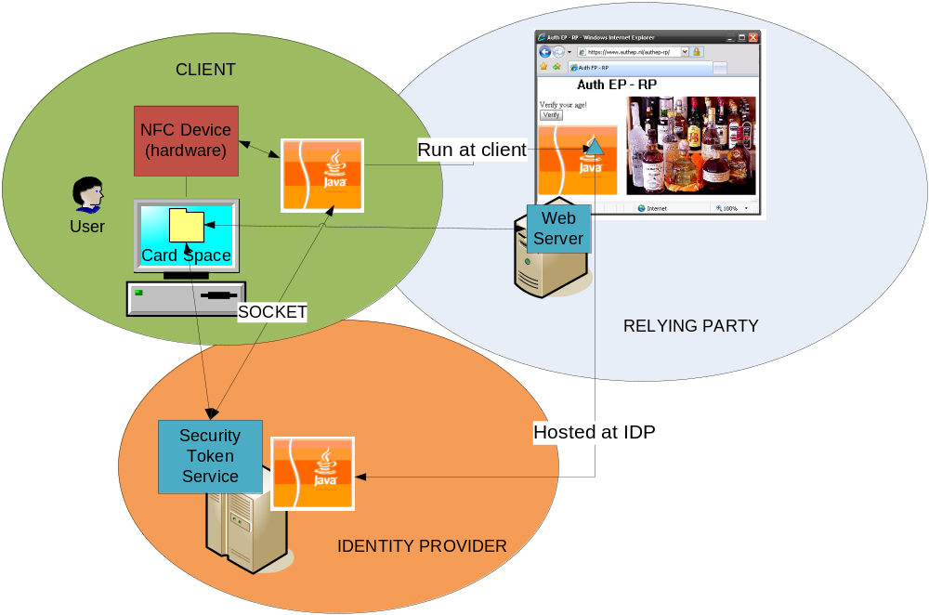
In the AuthEP scenario we have the traditional three parties that are used with CardSpace namely the relying party, identity provider (IdP) and client.
First the user will need to visit the IdP’s website and request a managed card. The managed card will be tied to the user’s passport and therefore the user should supply the BAC data to the IdP. The BAC data will be used later on by the IdP to allow communication with the passport.
After the user has acquired a managed card it can visit a relying party. The difference between a normal CardSpace session and the AuthEP case is an extra step between the client and the IdP after the client has requested a token at the IdP. In this extra step the IdP needs to check if the user has a valid passport and get the user’s details from this passport. In order to achieve this the IdP provides a Java Applet that can communicate with a digital passport. The relying party can link to this applet on its login page to make sure that the client is running it at the moment he’s signing in and requesting a token. The applet will first open a socket connection between the client and IdP. We use this socket connection for any communication between the IdP and the user’s passport. As soon as the client actually requests a token at the IdP, the IdP will look at the provided managed card and send the appropriate BAC data to the passport authenticating the IdP at the passport. The IdP will request the passports public key and security document. With the security document it can check if the public key has been signed by an appropriate government instance. It can then send a challenge to the passport which will prove not that the passport is authentic and not a simple clone. The IdP will request the minimal needed information from the passport to confirm to the token request. The token is send back to the client and from here on the normal CardSpace scenario can continue.

